**Name: ____________________________________ Id: ______________**

1. **Subtract the following two BCD numbers (0110 0101 0000 and 0011 0010 0000)(4 marks)**

|  |
| --- |
|  |
|  |
|  |
|  |
|  |
|  |
|  |
|  |
|  |
|  |
|  |
|  |

1. **Simplify the following function as SoP using tabular method: F(A,B,C)=∑m(0,2,4)+d(3,6,7) (3 marks)**

|  |
| --- |
|  |
|  |
|  |
|  |
|  |
|  |
|  |
|  |
|  |
|  |
|  |
|  |
|  |

1. **Simplify using k-map as SoP,**

**F(A,B,C,D,E)= $\overline{A}\overline{C}\overline{D}$ + $B\overline{C}\overline{D}\overline{E}+\overline{A}\overline{C}D\overline{E}+B\overline{C}D\overline{E}+d(A\overline{B}\overline{C}\overline{D}+A\overline{C}\overline{D}E)$**

**Then draw the logic diagram of the simplified function. (5 marks)**

|  |
| --- |
|  |
|  |
|  |
|  |
|  |
|  |
|  |
|  |
|  |

|  |
| --- |
|  |
|  |
|  |
|  |
|  |
|  |
|  |
|  |
|  |
|  |

|  |
| --- |
|  |
|  |
|  |
|  |
|  |
|  |
|  |
|  |
|  |
|  |
|  |

1. **Design a combinational circuit with 4-bit input number ABCD and produces an output F. The output F of the circuit is to be 1 if and only if the inputs represent a number that is completely divisible by 3 or 7. Note that the inputs (0000 and 1011) can't be received. Derive the simplified expression for output F as SoP. (4 marks)**

|  |
| --- |
|  |
|  |
|  |
|  |
|  |
|  |
|  |
|  |
|  |

|  |
| --- |
|  |
|  |
|  |
|  |
|  |
|  |
|  |
|  |
|  |

|  |
| --- |
|  |
|  |
|  |
|  |
|  |
|  |
|  |
|  |
|  |
|  |
|  |
|  |

1. **Calculate the propagation delay of the following logic diagram (3 marks)**

**Knowing the propagation delay of the following gates: NOT gate=3nsec AND gate & OR gate=10 nsec NAND gate & NOR gate=13 nsec XOR gate=20nsec XNOR gate=23 nsec**

**Then Draw the logic diagram of the following Boolean functions using NANDs only.**

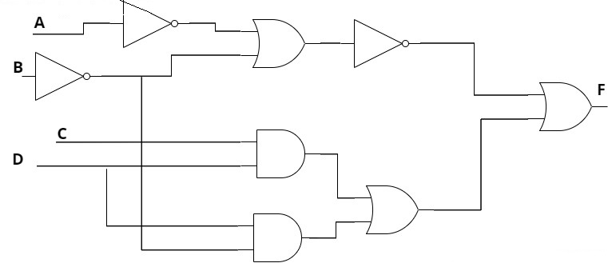

|  |
| --- |
|  |
|  |
|  |
|  |
|  |
|  |
|  |
|  |
|  |
|  |

1. **Determine the decimal representation of (011101001010010100101 )5421 (1 mark)**

|  |
| --- |
|  |
|  |
|  |
|  |
|  |
|  |
|  |
|  |
|  |